**CREATE UI TO INTERACT WITH APPLICATION**

1. **Login Page:**

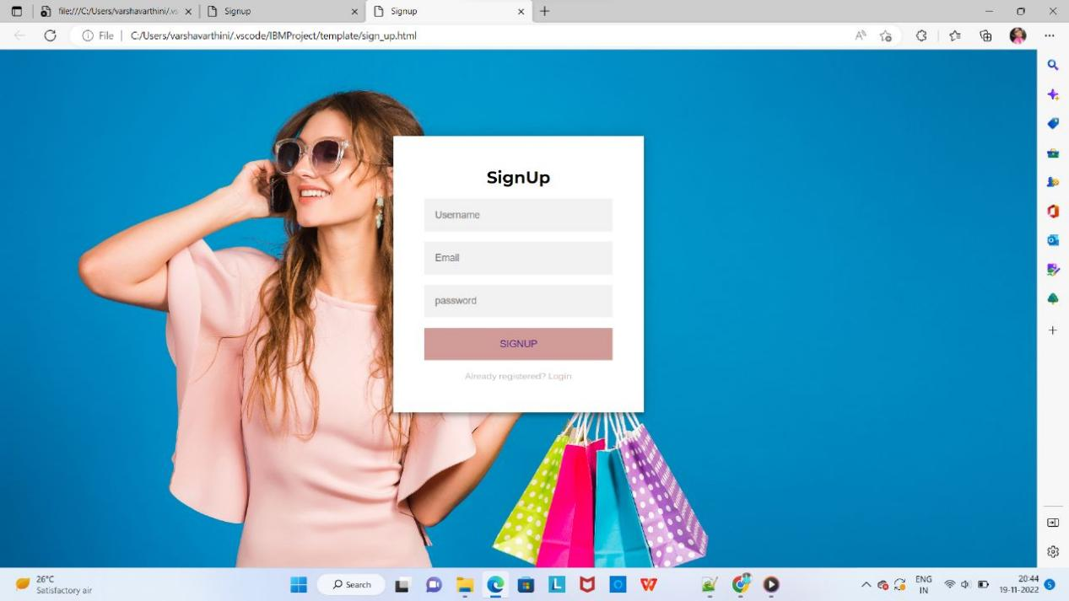

1. **Home Page:**

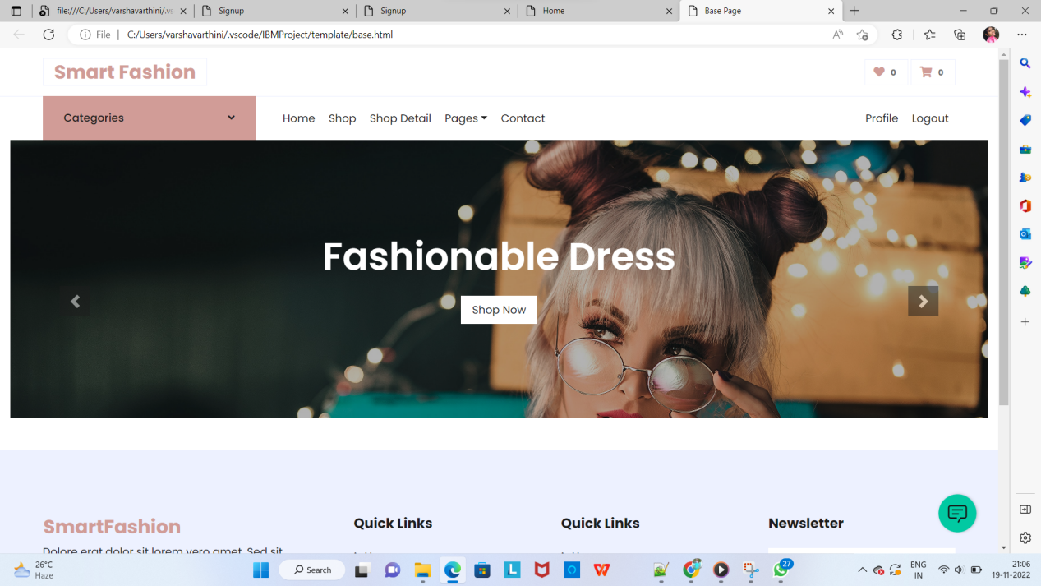

1. **Products Page:**

